UNIVERSITY OF ECONOMICS – VARNA
FACULTY OF MANAGEMENT
DEPARTMENT OF MANAGEMENT AND ADMINISTRATION

ABSTRACT
of a dissertation thesis
for the award of the academic degree "Doctor of Sciences"
in the professional field 3.7. Administration and Management

SOCIAL RESPONSIBILITY OF BUSINESS:
CONCEPTS, INSTITUTIONAL MECHANISMS, AND IMPACT EVALUATION

Svitlana Bilan

Varna,

2026

GENERAL CHARACTERISTICS OF THE STUDY
Relevance of the topic
Corporate social responsibility (CSR) is gaining increasing prominence in business management. In the contemporary context of global instability, deepening climate crisis, growing social inequality, disruptions in global value chains, accelerated digital transformation, and heightened public sensitivity to ethical standards of doing business, the social responsibility of business is no longer a facultative element of corporate philanthropy but is turning into a systemic component of strategic management.
For the modern company, responsibility toward employees, consumers, local communities, the state, the environment, and future generations is increasingly seen not as an external add-on to economic activity, but as an internal principle structuring corporate governance, decision-making, and the formation of long-term competitive advantage.
The topicality of the theme stems, first and foremost, from a change in the very logic of assessing business performance. Whereas earlier the focus was primarily on indicators of profitability, returns, and market value, today the importance of non-financial parameters is growing substantially: the quality of corporate governance, respect for human rights, environmental responsibility, transparency of reporting, ethical relations with stakeholders, and the company's capacity to adapt to crises.
Precisely for this reason, Environmental, Social, and Governance (ESG) criteria are increasingly being integrated into capital allocation mechanisms, investment strategies, credit ratings, and corporate risk assessment, making the level of development of a company's social responsibility system an economically relevant factor.
Secondly, the societal dimension of the issue is reinforced by the fact that business is increasingly viewed not only as an economic actor, but also as a fully fledged participant in social development. Companies are increasingly involved in addressing issues such as employment, gender equality, safe working conditions, support for local communities, human capital development, decarbonization of production, waste reduction, responsible resource consumption, digital ethics, and combating discrimination.
In this sense, the social responsibility of business functions as an institutional mechanism for aligning private economic interests with the goals of sustainable development and the public good.
Thirdly, the study of business social responsibility acquires particular significance in countries with post-transformation economies, where the institutional frameworks for responsible business conduct often remain unstable, incomplete, or internally contradictory. In such environments, not only formal norms matter – legislation, reporting standards, regulatory mechanisms – but also informal institutions such as trust, social capital, corporate culture, managerial values, and established patterns of interaction between business, the state, and civil society. Precisely for this reason, analyzing CSR within a neo-institutional framework makes it possible to explain more deeply why practices that are identical in form yield different results across countries, and why the mechanical transfer of models developed in mature market economies is not always effective for transitional societies.
Fourth, the importance of the topic is reinforced by regulatory changes that are shifting corporate social responsibility (CSR) from the realm of primarily voluntary initiatives into an increasingly stringent institutionalized framework. This refers above all to the expansion of non-financial reporting practices, the adoption of the Global Reporting Initiative (GRI), Carbon Disclosure Project (CDP), and Task Force on Climate-related Financial Disclosures (TCFD) frameworks, as well as the growing role of the EU Corporate Sustainability Reporting Directive (CSRD). Under these conditions, companies are compelled not only to declare their commitment to responsibility principles but also to build systems for monitoring, verification, ESG data management, internal audit, and external communication.
Despite the substantial number of publications on business social responsibility, the scholarly discourse remains fragmented. A significant share of research focuses on large transnational corporations in developed countries, whereas small and medium-sized enterprises and firms from post-transformation economies are underrepresented. The economic, social, and environmental dimensions of CSR are often analyzed in isolation, without adequately accounting for their interactions, the institutional environment, cultural factors, and crisis conditions.
Questions related to measuring CSR effectiveness, building integrated indicator systems, modeling the relationship between CSR and competitiveness, and examining the role of reputation and non-financial reporting in transforming responsible business at the strategic level remain underdeveloped.
Consequently, the relevance of this dissertation is determined by the need for a comprehensive theoretical interpretation of business social responsibility, a deepened institutional analysis of the mechanisms of its formation and implementation, and the development of a methodology for assessing the impact of CSR on enterprise development and competitiveness in a contemporary, turbulent environment.
Given the terminological diversity in the academic literature and institutional documents, it is necessary to distinguish between the key concepts used in this dissertation.
Social responsibility should be understood as a broad, systemic category that encompasses the obligations of all societal actors – the state, business, and civil society – with respect to sustainable development, social justice, and environmental protection. Corporate social responsibility is the organizational-level implementation of this broader concept and refers to the voluntary and strategic integration of social, environmental, and ethical considerations into the activities of corporations and large enterprises.
Business social responsibility (BSR), as used in the title of the thesis, is treated as a functional synonym of CSR, but with a broader scope that includes not only large corporations but also small and medium-sized enterprises, which constitute the predominant share of economic actors in post-transformation economies. In the dissertation, the terms corporate social responsibility (CSR) and business social responsibility (BSR) are used interchangeably to denote the organizational dimension of responsible business behavior, whereas the term "social responsibility," without further specification, refers to the broader systemic concept.
Aim, objectives, object, and subject of the study
The study aims to develop an integrated theoretical and methodological framework and practical recommendations for the formation, implementation, and monitoring of business social responsibility systems, understood as integrated organizational mechanisms, policies, procedures, tools, and practices through which enterprises institutionalize responsible behavior, as well as to substantiate the interrelationship between responsible business practices, organizational competitiveness, and the parameters of sustainable development under conditions of institutional transformation.
In line with this aim, the following research objectives are defined in the dissertation:
- To analyze the evolution of the conceptual foundations of business social responsibility – from early philanthropic practices to contemporary integrated ESG approaches.
- To clarify key concepts of business social responsibility and systematize the main theoretical approaches to its interpretation.
- To identify the cultural, institutional, and regulatory factors that mediate the formation and development of CSR in different national contexts.
- To systematize the mechanisms and tools for implementing business social responsibility at the enterprise level and in its interaction with the state and society.
- To develop and substantiate a system of indicators for assessing CSR effectiveness at the organizational and systemic level and to model the impact of business social responsibility on enterprise development and competitiveness.
- To construct econometric models that make it possible to evaluate the relationships between the level of CSR development, the quality of the institutional environment, and key business performance indicators.
- To analyze the role of non-financial reporting as a tool for transparency, accountability, and institutionalization of business social responsibility.
- To identify the specific features of adapting CSR strategies to crisis conditions, in particular pandemic, military, and technological shocks, and to formulate practical recommendations for businesses, investors, regulators, and researchers on improving the effectiveness of social responsibility systems.
The object of the study is the processes of business social responsibility in contemporary business ecosystems that evolve under the influence of global challenges and institutional transformations.
The subject of the study comprises the theoretical foundations, institutional mechanisms, assessment methodologies, and strategic tools for the implementation and monitoring of business social responsibility, examined through the prism of their influence on organizational competitiveness and sustainable development.

Main scientific thesis and research hypotheses
The dissertation is based on the thesis that business social responsibility constitutes an institutionally embedded and organisationally integrated strategic mechanism through which enterprises transform their interactions with stakeholders into sustainable competitive advantages. The effectiveness of this mechanism is determined by the interplay between the quality of the institutional environment, internal corporate policies and governance mechanisms, non-financial reporting tools, and reputational capital, which, in their dynamics, shape the relationship between responsible behavior, sustainable development, and competitiveness at both micro and macro levels.
In this sense, business social responsibility is viewed not as a peripheral function of corporate governance but as a systemic factor in creating long-term value, organizational resilience, and legitimacy for contemporary organizations.
To test the formulated thesis, nine research hypotheses have been derived, structured according to the logic of the transition from the macro-institutional level to organizational mechanisms and outcomes.
Hypothesis 1. National sustainable development systems – measured through composite indicators of social progress, human development, economic freedom, innovation capacity, subjective well-being, and environmental performance – are positively associated with national competitiveness. In this dissertation, the term "CSR systems" used in the research purpose refers to firm‑level configurations of CSR approaches and mechanisms, whereas "national sustainable development systems" in Hypothesis 1 denote country‑level institutional aggregates captured through these composite indices.
Hypothesis 2: The development of CSR reflects both a gradual historical evolution from philanthropic to strategic paradigms and rapid adaptation to crisis conditions (COVID-19, military conflicts, the digital revolution), demonstrating how external shocks accelerate the transformation of CSR practices.
Hypothesis 3: Models of public-private cooperation in CSR implementation vary systematically based on institutional contexts, regulatory frameworks, and governance mechanisms in different jurisdictions.
Hypothesis 4: The implementation of internal CSR policies, including codes of ethics and governance standards, positively correlates with external ESG ratings and stakeholder assessments.
Hypothesis 5: Companies' adoption of independent non-financial reporting frameworks (GRI, CDP, TCFD) increases CSR transparency and contributes to improved ESG ratings and stakeholder trust. H5 examines how the adoption of independent frameworks such as GRI, CDP, and TCFD serves as an external signaling mechanism , increasing CSR transparency and reflected in improved ESG ratings and stakeholder trust.
Hypothesis 6: Corporate reputation is both the driving force and the result of effective CSR initiatives, creating a mutually reinforcing cycle of stakeholder trust and competitive advantage.
Hypothesis 7: Systematic adoption of recognized non-financial reporting frameworks (e.g., GRI, CDP, TCFD, CSRD) strengthens CSR effectiveness by enhancing organizational transparency, accountability, and stakeholder engagement. H7 focuses on the internal governance dimension of reporting, hypothesizing that the systematic use of recognized frameworks, including CSRD requirements, enhances organizational transparency, accountability, and stakeholder engagement, thereby strengthening the overall effectiveness of CSR.
Hypothesis 8: The dynamics of CSR development are determined by complex interactions between institutional quality (rule of law, regulatory efficiency, control of corruption), regulatory frameworks, cultural contexts, and crisis conditions, which create both opportunities and barriers.
Hypothesis 9: Strategic integration of CSR into corporate decision-making processes contributes to improved organizational performance and competitiveness — as evidenced by country-level composite indicators (IMD World Competitiveness Index, Institutional Risk Index, and CSR return on investment metrics) — while institutional weaknesses at the country level increase transaction costs (monitoring, enforcement, coordination) that amplify implementation risks and reduce CSR effectiveness.
For the empirical testing of these hypotheses, a sequential operationalization scheme has been developed that links the theoretical constructs to measurable indicators at the systemic and organizational levels. At the macro level, national sustainable development systems are represented through composite indices (SDG Index, Human Development Index, Economic Freedom Index, Global Innovation Index, World Happiness Score, Environmental Performance Index), while the IMD World Competitiveness Index measures competitiveness. At the micro- and meso-levels, business social responsibility is specified through indicators of CSR/BSR practice implementation, corporate reputation, the use of non-financial reporting frameworks, and characteristics of the institutional environment.
Theoretical and methodological foundations and research methods
The theoretical and methodological foundation of the dissertation is the neo-institutional approach, which views business social responsibility as the outcome of interactions between formal and informal institutions. This approach explains how legislation, standards, regulatory requirements, corporate rules, cultural norms, values, and trust-based practices shape concrete patterns of responsible business behavior across different societies.
Alongside the neo-institutional approach, the study employs propositions from stakeholder theory, corporate reputation theory, the resource-based view of the firm, as well as contemporary concepts of sustainable development, ESG, and non-financial reporting. Their combination enables the construction of an integrated analytical framework within which CSR is conceptualized as a multi-layered phenomenon encompassing systemic, organizational, managerial, communicative, and outcome-related dimensions.
The research methodology is mixed. The quantitative component involves bibliometric analysis of CSR-related publications in the Scopus and Web of Science databases for the period 1982–2023 with network visualisation using VOSviewer; correlation and regression analysis to identify relationships between indicators of social responsibility, sustainable development and competitiveness; and analysis of international composite indices, including the Global Competitiveness Index, SDG Index, Human Development Index, Global Innovation Index, World Happiness Score and Environmental Performance Index.
The empirical base of the quantitative part consists, in particular, of data from 27 European Union member states, which enables testing hypotheses on the relationship between the development of a sustainable environment and competitiveness, as well as the role of institutional factors in creating favorable preconditions for CSR development. The econometric models in the study are interpreted as tools for detecting statistically significant relationships rather than as a basis for simplified causal conclusions, reflecting the research design's methodological caution.
The qualitative component of the study includes a systematic literature review, a comparative institutional analysis of business social responsibility models, case studies of corporate practices and crisis adaptation, and a content analysis of international standards and regulatory documents in the field of non-financial reporting and corporate responsibility. This combination of methods enables not only the description of existing practices but also the identification of the structural mechanisms by which CSR is integrated into corporate governance, monitoring systems, reputation management, and strategic planning.
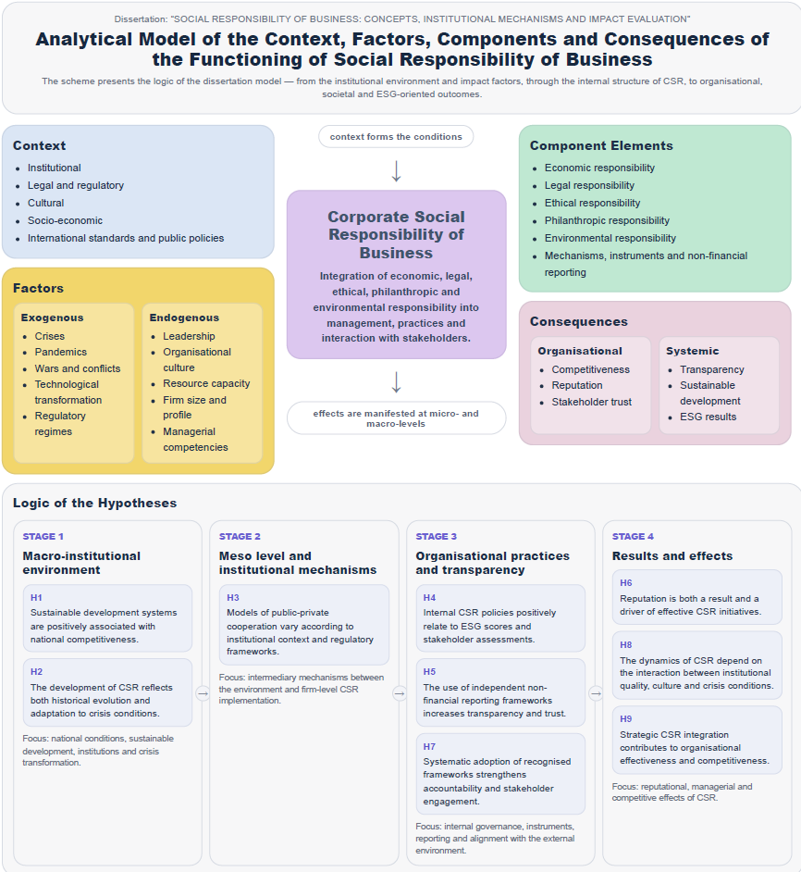
Figure 1. Analytical model of the context, factors, components, and consequences of business social responsibility

The data source consists of international statistical databases, materials from international organizations, corporate sustainability reports, and results of academic studies and sectoral assessments covering the period 1982–2023, with particular emphasis on post-transformation economies.

Boundaries and limitations of the study
The dissertation clearly delineates the applicability of the obtained results, which is an important indication of academic integrity and methodological rigor. The temporal limitations stem from the fact that the bibliometric analysis and a substantial part of the empirical analysis cover the period 1982–2023. This makes it possible to reconstruct the historical evolution of CSR from its early conceptualizations to contemporary regulatory models, but does not fully capture the most recent consequences of decisions introduced in 2024–2025, in particular, the further phases of CSRD implementation and the convergence of taxonomic approaches.
The geographical limitations stem from the focus on post-transformation economies, primarily in countries characterized by heightened volatility, regulatory asymmetries, and a significant role for informal practices. This focus is analytically justified, yet it also restricts the direct generalization of the conclusions to mature market economies, where business social responsibility is embedded in more stable legal and institutional structures.
The methodological limitations stem from the use of aggregated indicators and statistical models, which may entail problems of endogeneity, omitted variables, linear specification, and ambiguity in causal interpretation. Nevertheless, these risks are explicitly acknowledged and mitigated through diagnostic procedures, robustness checks, and a cautious interpretation of the results.
Source-related limitations arise because international indices and corporate disclosures do not represent organizations of different sizes or levels of transparency equally. This creates a certain visibility bias in favor of better-resourced and more reporting-intensive entities. However, the use of multiple data types and the distinction between measurement and actual corporate behavior have enabled partial neutralization of this risk.
A further limitation of the study is that the modeling of the impact of business social responsibility on development and competitiveness is conducted at the macro level, using composite global indices for 27 EU member states. This does not allow for direct conclusions about causal relationships at the micro level (enterprise) and points to directions for future empirical research.
Scientific novelty of the results
The scientific novelty of the dissertation is expressed in a system of interconnected theoretical, methodological, and empirical results that deepen the understanding of business social responsibility as a strategic institutional mechanism of contemporary corporate development. These results manifest themselves at two interrelated levels: a scientific-theoretical level, linked to the conceptualization and neo-institutional framing of business social responsibility, and an applied-scientific level, relating to methodological tools, assessment, and practical recommendations.
The study systematically integrates the economic, social, environmental, institutional, and cultural dimensions of business social responsibility into a single analytical framework, enabling it to reconceptualize CSR not as a set of scattered practices but as a structured mechanism for creating long-term value, resilience, and the company's legitimacy. The methodological toolkit for assessing CSR effectiveness is enhanced by combining quantitative and qualitative indicators, composite indices, monitoring approaches, reputation capital analysis, and non-financial reporting mechanisms. In this context, an approach is proposed that links the outcomes of a firm's socially responsible activities to both internal organizational parameters and macroeconomic development indicators.
Further development is provided to substantiate the relationship among the quality of the national institutional environment, sustainable development, and competitiveness. Based on comparative analysis and econometric modeling of data for 27 European Union member states, it is demonstrated that indicators of sustainable development, human development, economic freedom, innovation capacity, subjective well-being, and environmental performance have a positive, statistically significant relationship with national competitiveness, thereby creating a favorable macro-institutional environment for the development of business social responsibility.
Within the enhanced methodological toolkit for assessing business social responsibility, the role of corporate reputation is further specified as a two-way mechanism: it is not only the result of effective CSR practices but also a resource that strengthens a company's capacity to maintain consistent and systematic strategies of responsible conduct.
The scientific understanding of non-financial reporting is deepened by framing it not merely as a communication tool but as a mechanism for institutionalizing business social responsibility, enhancing accountability, verifiability, and data comparability, and engaging stakeholders in the system for assessing corporate responsibility.
The thesis on the contextual embeddedness of business social responsibility models is also further developed. It is demonstrated that formal regulatory mechanisms, cultural norms, managerial practices, digital monitoring tools, and crisis conditions create a multidimensional environment in which CSR assumes different configurations and cannot be effectively implemented through a universal template without accounting for institutional context.
Practical significance of the results
The practical significance of the dissertation lies in the fact that its theoretical propositions, methodological approaches, and analytical conclusions can be applied in several practical domains.
First, the research findings are of interest to economic actors seeking to integrate social responsibility into corporate strategy, risk management systems, stakeholder engagement mechanisms, and non-financial reporting. The proposed approaches can be used to design internal policies, corporate codes, KPI models, and systems to assess and monitor CSR effectiveness.
Second, the dissertation's conclusions are useful for public authorities, regulators, and policymakers, as they provide a basis for improving institutional mechanisms to support responsible business, creating incentives for non-financial disclosure, enhancing the transparency of corporate activity, and strengthening partnerships between business, the state, and civil society.
Third, the research results can be used by investors, analysts, auditors, and rating agencies to gain a deeper understanding of how the quality of corporate governance, accountability, reputation, and the institutional environment affect the long-term sustainability of businesses.
Fourth, the dissertation's methodological principles and empirical results can be further applied in the educational process to update curricula and teach courses on corporate social responsibility, sustainable development, social governance, strategic management, reputation management, sociology of organizations, and non-financial reporting.
Structure and scope of the dissertation
The dissertation is 311 pages long and consists of an introduction, three chapters, a conclusion, and a list of references. The overall logic of the work is built around three interrelated analytical levels: the conceptualization of business social responsibility; the development of mechanisms and tools for its implementation; and the formation of a methodological basis for evaluating and monitoring its effectiveness.
The first chapter is devoted to the conceptual, theoretical, and institutional foundations of business social responsibility. The second chapter focuses on the mechanisms, tools, and models for implementing CSR at the enterprise level and within the broader institutional environment. The third chapter covers methods of assessment, monitoring, reputational analysis, and the consideration of non-financial reporting as a driver of transparency and CSR development.

MAIN CONTENT OF THE DISSERTATION
Chapter 1. Conceptual foundations of business social responsibility
The first chapter provides an in-depth conceptualization and historical reconstruction of corporate social responsibility, drawing a clear distinction between "social responsibility" as a macro-level societal construct and "CSR" as the firm-level, managerial dimension of this responsibility. Social responsibility is examined as a system of obligations for the state, business, and civil society regarding sustainable development, whereas CSR is analyzed as an organizational practice embedded in corporate strategy, governance, and stakeholder engagement. In this context, the term "business social responsibility" is used as an overarching concept, while the analysis is operationalized through global scientific and regulatory CSR frameworks, including ISO standards, GRI, CSRD, and related approaches to non-financial reporting.
It is shown that the contemporary transformation of CSR from a moral duty into a strategic management tool is largely driven by the development of stakeholder theory and the institutionalization of CSR as a mechanism for managing risks, reputation, and the resilience of business models. Particular emphasis is placed on the role of corporate irresponsibility and scandals (such as the cases of Shell, Nike, etc.) as negative catalysts for the emergence of codes of conduct, non-financial reporting standards, and due diligence procedures.
At the theoretical level, the first chapter integrates and critically analyses several leading approaches to CSR and corporate (ir)responsibility. Carroll's pyramid, with its economic, legal, ethical, and philanthropic levels, is treated as a basic yet in need of further refinement framework of corporate obligations, related to more recent models of corporate social performance, Elkington's triple bottom line, and the concept of corporate irresponsibility.
The causes of systemic failures are examined – profit maximization without corrective mechanisms, oversight deficits, short-term incentives, unethical leadership – as well as their connection to the need for regulatory and institutional safeguards. Particular attention is paid to corporate crime and white-collar offenses as the structural antithesis of CSR, illustrated through emblematic cases from Bhopal, Nestlé, and Chornobyl to Volkswagen, Wells Fargo, and Facebook, which empirically support the thesis that CSR has also evolved as a response to a historical pattern of corporate failures.
The analysis shows that the relationship between social responsibility and economic performance is context-dependent and cannot be reduced to a single causal scheme. A special place in the chapter is occupied by the neo-institutional analytical framework, through which CSR is viewed as the outcome of interactions between formal institutions – legislation, standards, regulations, supervisory mechanisms – and informal norms such as culture, ethics, public opinion, and expectations of legitimate corporate behavior. In this perspective, the "cultural and institutional loci" of CSR are defined as: the culture of responsibility; the legal system; ethical standards; the role of the media and civil society; institutional support; the investment community; international standards; and educational and scientific institutions.
Hofstede's cultural dimensions – uncertainty avoidance, power distance, individualism/collectivism – and their influence on the priorities and forms of CSR and ESG reporting are examined, with emphasis on the fact that high uncertainty avoidance may stimulate the formalization and standardization of non-financial reporting while simultaneously leading to excessive bureaucratization. In contrast, lower power distance facilitates partnership-based models of interaction with communities.
On this basis, the risk of "window-dressing" CSR (decoupling) is identified in countries with weak institutions, where formal reporting may coexist with systemic irresponsibility. This phenomenon is linked to globalization processes, which simultaneously drive the harmonization of standards and sharpen tensions between supranational requirements (CSRD, UN Global Compact, ISO) and local institutional realities.
Globalization is examined as a factor in the emergence of "hybrid" institutions and practices of reflexive governance, in which enterprises seek to reconcile international expectations with specific national and regional conditions.
Building on the sustainable development paradigm, subsection 1.3 situates CSR firmly within the framework of economic, social and environmental sustainability. The starting points are the Brundtland Report and the UN Sustainable Development Goals, which demonstrate that the traditional profit-maximization logic that ignores social and environmental constraints becomes incompatible with the long-term viability of economic systems. The three-pillar model of sustainable development is interpreted not merely as an abstract diagram but as a concrete managerial imperative: economic viability, environmental sustainability, and social acceptability must be ensured simultaneously. In this context, CSR is viewed as a mechanism for aligning these dimensions through the management of costs, risks, reputation, innovation, and stakeholder relations.
Chapter One also traces the shift from voluntary CSR initiatives towards increasingly mandatory requirements for non-financial reporting and the integration of ESG approaches into the architecture of sustainable finance. The roles of the CSRD, the European Sustainability Reporting Standards (ESRS), the EU Taxonomy, and the SFDR are analyzed, as well as the importance of XBRL tagging and external audit for the reliability and comparability of non-financial data. It is shown that the digitalization of reporting – through IoT solutions, AI-based analytics, and blockchain technologies – transforms CSR from an episodic communication product into a continuous data management process that is gradually approaching the status of financial information.
At the macro level, the concept of "state social responsibility" is developed as a system of guarantees, standards, and institutions that protect fundamental social rights, reduce inequalities, and create a framework for responsible business conduct, thereby substantiating the relationship among CSR, competitiveness, human development, and the quality of public governance.
The concluding section of the first chapter presents a bibliometric analysis of the CSR research field, based on publications in Scopus and Web of Science. The main thematic clusters are identified, and the transition is shown from ethical and definitional debates to contemporary ESG approaches and the understanding of CSR as a source of competitive advantage and a tool for crisis management.
The bibliometric analysis of publications indexed in Scopus and Web of Science for the period 1982–2023 shows that CSR/BSR has gradually transformed from a marginal research topic into a dense, rapidly developing scientific field. While the number of publications remained relatively limited and uneven until the early 2000s, exponential growth thereafter reflects the institutionalization of CSR across both academic discourse and business practice.
The overall trajectory of this growth is illustrated by the dynamics of publications devoted to CSR over the period under review.
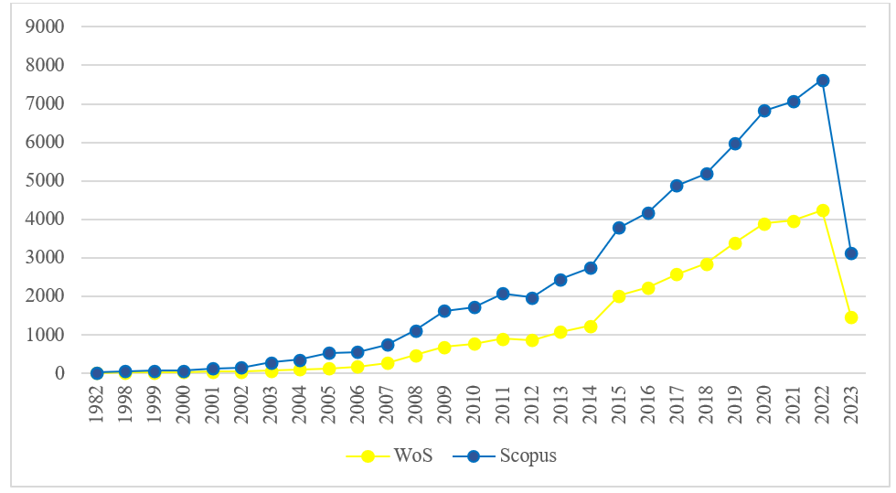
Figure 2. Dynamics of publications in Scopus and Web of Science, 1982–2023
Source: Compiled by the author based on data from the Scopus and Web of Science databases.
The bibliometric review justifies the choice of the neo-institutional framework, the focus on post-transformation economies, and the need for an integrated methodology to assess business social responsibility. In subsection 1.1, the content, significance, and historical foundations of corporate social responsibility are examined. It is shown that the contemporary understanding of CSR is formed at the intersection of economic theory, management thought, business ethics, and societal practice. Particular attention is paid to the transition from a narrow interpretation of responsibility as voluntary philanthropy to the notion of CSR as a multidimensional system of business obligations towards society, the environment, and stakeholders.
In this part, the key stages in the formation of CSR are reconstructed: from early practices of industrial philanthropy and paternalistic models of social care to the contemporary stage, in which social responsibility is embedded in corporate strategy, risk management systems, compliance procedures, and non-financial disclosure. It is demonstrated that, at this stage, CSR cannot be properly understood outside the context of ESG, sustainable development, accountability, and cross-sector collaboration.
An important outcome of the subsection is the systematization of the main theoretical approaches to the relationship between CSR and firm performance, particularly through the lenses of stakeholder theory, reputation theory, and the resource-based view. These approaches link responsibility with the long-term sustainability of business.
Subsection 1.2 is devoted to the cultural and institutional aspects of business social responsibility. The author argues that CSR does not develop in an institutional vacuum: its configuration depends on the balance between formal norms – legislation, standards, regulatory requirements, investor demands – and informal institutions such as values, trust, managerial habits, and norms of social interaction. Applying the neo-institutional approach makes it possible to explain why business social responsibility takes different forms across countries, ranging from predominantly voluntary, reputation-oriented models to strongly regulated systems with embedded accountability mechanisms.
A particularly important place in this subsection is occupied by the bibliometric analysis of scholarly publications on CSR in Scopus and Web of Science for the period 1982–2023. The results make it possible to trace the geography of scientific output, thematic clusters, citation dynamics, and shifts in research focus – from the dominance of ethical and philanthropic dimensions to complex ESG approaches, issues of crisis resilience, transparency, digital tools, and accountability.
Beyond the volume of scholarly output, the internal structure of the research field is crucial. Through an analysis of keyword co-occurrence in the Scopus database using VOSviewer, several major thematic clusters are identified that link CSR with sustainable development, finance, corporate governance, communication and reporting, business ethics, and strategic management. These clusters reveal how CSR is embedded in a broad spectrum of economic, social, and environmental debates.
The configuration of these clusters and their relationships can be visualized through a network map of concepts related to corporate social responsibility (Figure 4).
The analysis also reveals the unevenness of the global academic landscape and the relative underrepresentation of post-transformation societies in international discourse, further confirming the study's scientific and applied relevance. In addition to analyzing international discourse in the Scopus and Web of Science databases, the research examines the most-cited works of Bulgarian scholars in economics and management in the fields of corporate social responsibility and non-financial reporting. This makes it possible to integrate established Western theoretical traditions with specific national experience and to avoid a one-sided "over-valuation" of Western conceptual frameworks when interpreting the results.
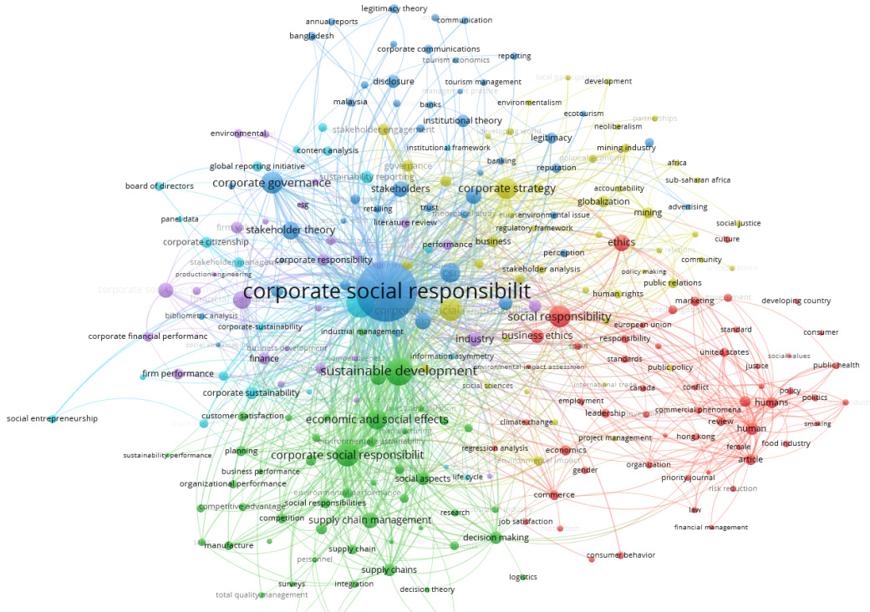
Figure 3. Network map of concepts related to corporate social responsibility (VOSviewer)
Source: Compiled by the author based on data from the Scopus and Web of Science databases.
To complement the bibliometric analysis of scholarly articles, the dissertation also examines the long-term dynamics of the discourse on CSR and related concepts in the broader corpus of published literature. Using the Google Books Ngram Viewer tool, it traces the frequency of the terms "social responsibility", "corporate social responsibility", and "Sustainable Development Goals (SDGs)", allowing us to see how these ideas gradually enter and consolidate within the global intellectual agenda.
The temporal trajectory of these terms shows a clear, sustained increase in attention to CSR and the Sustainable Development Goals over recent decades.
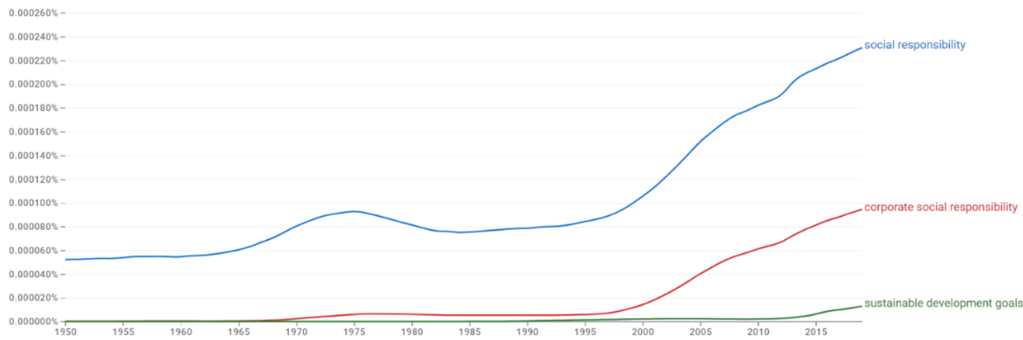
Figure 6. Frequency of mentions of social responsibility, CSR, and SDGs in the Google Books corpus (Ngram Viewer)
Source: Author's elaboration based on data from Google Books Ngram Viewer.
In subsection 1.3, business social responsibility is examined in the context of sustainable development and the interactions among the state, business, and society. It is demonstrated that CSR is one of the key channels through which the private sector can contribute to achieving the UN Sustainable Development Goals while simultaneously adapting its business models to new expectations for social and environmental performance. Particular attention is paid to cross-sector partnerships, public policy, public-private cooperation, and the role of social responsibility in building public trust.
Overall, the first chapter concludes that business social responsibility is not a static norm or an abstract moral requirement. It is a dynamic institutional construct that changes under the influence of historical processes, global crises, regulatory innovations, the evolution of societal expectations, and the internal transformation of corporate governance. For this reason, further research requires a shift from describing value foundations to analyzing the specific mechanisms for implementing CSR, which is undertaken in the second chapter of the dissertation.

Chapter 2. Methodology for forming the business social responsibility mechanism
In the second chapter, business social responsibility is considered at the conceptual level, organizational-managerial mechanisms, and empirical macro-analysis. First, a systemic concept of CSR is developed as an integrated management system that ceases to be a peripheral charitable activity and becomes a strategic element of corporate governance linked to risk management, innovation, and value creation. A distinction is proposed between the CSR model's macro- and meso-level institutional configurations. CSR strategy (long-term firm-level decisions) and CSR approach (management philosophy – compliance-oriented, stakeholder-oriented, shared value, etc.).
In this context, the notion of a "corporate social responsibility system" is introduced as an aggregate of approaches, policies, practices, and mechanisms through which social, environmental, and ethical dimensions are integrated into the enterprise's operational activities, with a clear orientation towards sustainable development and the limitation of negative external effects. The distinction between strategy and policy is emphasized: strategy defines the long-term direction and priorities, while policies operationalize them through rules, procedures, codes of conduct, and specific management mechanisms.
Subsection 2.1 systematizes the mechanisms for implementing CSR, presenting them not as a set of separate initiatives but as a coherent management circuit. Key blocks are identified: strategic integration of CSR into corporate strategy; internal policies and codes; stakeholder engagement; environmental responsibility; social programs; transparency and business ethics; responsible governance and control. Each block is described through the prism of specific managerial decisions – formulation of SMART objectives, development of digital monitoring systems, institutionalized forms of stakeholder dialogue, environmental management systems, programs to support vulnerable groups, codes of ethics, internal audits, and the integration of CSR into budgeting, public procurement, and human resource management.
The evolution of corporate social responsibility is traced not only at the level of enterprise practices but also within the scholarly discourse, where the conceptual foundations of CSR, neo-institutional approaches, implementation mechanisms, assessment and monitoring, and crisis-resilient models have been developed sequentially. The following table summarises the main thematic strands and key authors that shape contemporary understanding of CSR.

Table 1. Evolution of research on corporate social responsibility: main thematic strands and key authors
Thematic area | Key contributions and authors
Conceptual framework of CSR | Davis (1960) formulates the "Iron Law of Responsibility", arguing that social responsibilities must be commensurate with business power. Carroll (1979) developed the four-level CSR framework (economic, legal, ethical, and philanthropic), which serves as a foundational model for understanding CSR's multidimensional nature and its integration into corporate strategy.
Neo-institutionalism and CSR | Neo-institutional perspectives, exemplified by the volume Culture Matters (Harrison & Huntington, 2001), emphasize how cultural norms, institutional configurations, and societal expectations shape CSR adoption and diffusion across countries, highlighting cross-national variation in responsible business practices.
Implementation mechanisms | Porter & Kramer (2011) introduce the "Creating Shared Value" concept, linking competitive advantage with societal value creation and encouraging firms to design products and business models that address social and environmental problems. Crane & Matten (2016) systematize CSR implementation strategies, including philanthropy, responsible supply chain management, and stakeholder engagement.
CSR assessment and monitoring | International standards such as ISO 26000 and the UN Global Compact provide reference frameworks for assessing and monitoring CSR performance and ESG transparency. Wood's (1991) Corporate Social Performance (CSP) model and Elkington's (1994) Triple Bottom Line approach further institutionalize multidimensional evaluation by integrating economic, social, and environmental impacts.

Table 1. Evolution of research on corporate social responsibility: main thematic strands and key authors (continued)
Challenges and prospects | Blowfield & Frynas (2005) analyze the difficulties of implementing CSR in contexts marked by institutional voids, weak governance, and quasi-legal environments, showing how regulatory gaps, corruption, and enforcement deficits constrain responsible business conduct and limit the transformative potential of CSR.
Crisis-resilient CSR | Boin et al. (2013) underline the tension between immediate crisis response and the continuity of long-term CSR commitments. He & Harris (2020), as well as Shen & Benson (2016), demonstrate that firms with embedded CSR systems can mobilize resources more effectively in crises (e.g., COVID-19), turning crisis-aligned CSR initiatives into sources of reputation, stakeholder loyalty, and organizational resilience.
Source: Compiled by the author based on a synthesis of the CSR literature [Davis, 1960; Carroll, 1979; Wood, 1991; Harrison & Huntington, 2001; Blowfield & Frynas, 2005; Porter & Kramer, 2011; Boin et al., 2013].
At the organizational level, the evolution of CSR is described as a sequence of stages – defensive (denial of responsibility), functional (isolated, unsystematic initiatives), strategic (embedding CSR in long-term strategy), and civil (promoting CSR principles within the broader business environment). This typology serves both analytical and practical purposes, providing a framework for assessing the maturity of CSR systems within individual companies. It is shown that organizational structures (a specialized unit, a cross-functional committee, a dedicated officer, or integration into existing functions) serve as instruments for institutionalizing CSR rather than ends in themselves; what is decisive is the extent to which CSR permeates all key management processes.
Subsection 2.2 is devoted to CSR tools, viewed as the "operational infrastructure" of the system. Program-oriented tools – grants, philanthropy, sponsorship, social investments, corporate volunteering – are traced through their transformation from ad hoc donations to long-term programs aligned with sustainable development priorities and the competitive strengths of enterprises. Market-oriented tools – cause-related marketing, impact investing, green and social bonds – highlight the fusion of business logic and social goals, turning consumers and investors into co-creators of social value. A highly developed group includes accountability and measurement tools such as integrated reporting, application of GRI, SASB, TCFD, and CSRD, disclosure indices, and external verification. They function simultaneously as communication channels and drivers of internal organizational change, while the standardization of reporting leads to the emergence of meta-tools – disclosure indices that enable benchmarking and the identification of gaps, but do not substitute for real effectiveness; rather, they illuminate the discrepancies between symbolic declarations and substantive results.
The development of digital technologies – IoT, blockchain, ESG data analytics, and AI-based solutions – is shown as a factor driving a qualitative transformation of CSR: from episodic annual reporting towards continuous monitoring and predictive analysis of risks in global value chains. Stakeholder-related tools are also examined: stakeholder mapping, materiality analysis, multi-stakeholder forums, and grievance mechanisms, which transform CSR from one-way communication into a process of shared management of expectations and impacts. At the same time, the chapter emphasizes a critical conclusion: in quasi-legal and weakly institutionalized environments, these same tools can coexist with corporate irresponsibility, turning CSR into a "shop window" without a deep transformation of practices. It follows that the effectiveness of these tools depends fundamentally on the quality of the institutional environment and the existence of mechanisms to sanction the opportunistic use of CSR rhetoric.
In subsection 2.3, the focus shifts from the micro level (enterprises) to the macro level (national economies), modeling how sustainable development systems and institutional conditions are linked to national competitiveness. An analytical framework is constructed that clearly distinguishes between two interconnected planes: the systemic level – institutions, regulations, and global composite indices – and the organizational level – CSR strategies, tools, and practices at the enterprise level.
Within the second chapter, the emphasis is placed precisely on the systemic level and on testing the first block of hypotheses (H1–H3, H8, H9), related to the evolution of CSR, the models of interaction between the state and the private sector, and the role of the institutional environment in the development of responsible business. The central hypothesis is that integrated sustainable development systems, which combine social, economic, and environmental dimensions, are positively associated with macroeconomic competitiveness and create a favorable context for the development of CSR. To ensure a transparent link between the theoretical propositions and empirical testing, a summary table (Table 2) has been developed to operationalize the hypotheses, connecting key constructs, their operational definitions, and the indicators used to measure them.

Table 2. Operationalization of the research hypotheses
Hypothesis | Key constructs | Operational definition (brief) | Indicators/metrics
H1 | Sustainable development; national competitiveness | Degree of integration of social, economic, and environmental dimensions in the national sustainable development system and their relationship with macro-level competitiveness. | SDG Index, Human Development Index, Economic Freedom Index, Global Innovation Index, World Happiness Score, Environmental Performance Index, IMD World Competitiveness Index
H2 | CSR evolution; crisis adaptation | Transition from philanthropic to strategic CSR models and the speed/intensity of changes in CSR approaches following external shocks (pandemics, wars, technological crises). | Share of firms with strategic CSR plans versus philanthropic programs; number of new CSR initiatives in crisis years; time lag between the crisis and the revision of the CSR strategy

Table 2. Operationalization of the research hypotheses (continued)
H3 | Public-private partnership in CSR | The level of institutionalized cooperation between the state and business in implementing CSR programs depends on the regulatory and governance frameworks in place. | Number and type of PPP initiatives; existence of formal public support schemes; degree of centralization/decentralization of CSR governance
H4 | Internal CSR policy and governance | Existence, maturity, and enforcement of internal CSR policies (codes of ethics, oversight structures, corporate governance standards). | Existence of a code of ethics; CSR/ESG committee at board level; internal rules on anti-corruption, labor standards, etc.
H5 | Non-financial reporting and ESG ratings | Adoption of recognised non-financial reporting frameworks and their impact on transparency, external ESG ratings, and stakeholder trust. | Adopted frameworks (GRI, CDP, TCFD, CSRD); presence of external assurance; ESG rating; trust and perception indices
H6 | Corporate reputation as a resource | Reputation is an intangible asset that strengthens a company's ability to maintain consistent and systematic CSR strategies. | Reputation indices (e.g., RepTrak); assessments of perceived external/internal prestige; stability of CSR budgets over time
H7 | Reputation and stakeholder trust | The interrelationship between the level of reputational capital and stakeholders' willingness to buy from, invest in, and support the company in times of crisis. | Reputation indices; purchase/investment intentions; indicators of employee loyalty and engagement

Table 2. Operationalization of the research hypotheses (continued)
H8 | Institutional environment and CSR dynamics | Influence of institutional quality (rule of law, regulatory effectiveness, control of corruption) on the development and stability of CSR practices. | Institutional quality indices (e.g., Worldwide Governance Indicators), the degree of diffusion of CSR practices, and the persistence of CSR initiatives over time
H9 | Institutions, sustainable development, and competitiveness | Combined impact of institutional quality and the level of sustainable development on national competitiveness and the potential for CSR. | Institutional quality indices; SDG/HDI/Innovation/Happiness/EPI; IMD Competitiveness Index; aggregated assessments of the CSR context
Source: developed by the author based on a synthesis of the literature on CSR, the institutional environment, reputation, and competitiveness.

The central hypothesis is that integrated sustainable development systems, which combine social, economic, and environmental dimensions, are positively associated with macroeconomic competitiveness and create a favorable context for CSR development. To operationalize this hypothesis, data from 27 European Union member states for the period 2024–2025 are used. A system of indicators is constructed in which the SDG Index, Human Development Index, Economic Freedom Index, Global Innovation Index, World Happiness Score, and Environmental Performance Index function as independent variables, and the IMD World Competitiveness Index as the dependent variable. A careful descriptive analysis shows no extreme values and approximately normal distributions, which allows the use of classical regression models. The correlation matrix shows stable positive relationships between competitiveness and all six predictors, with the strongest associations observed for innovation capacity and subjective well-being, and substantial intercorrelations among the predictors, without reaching critical levels of multicollinearity.
The OLS regression model, in which the six composite variables explain the IMD index, exhibits high explanatory power (R² of around 0.80) and a statistically significant overall F-statistic. Diagnostic tests for normality, homoskedasticity, and autocorrelation do not reveal substantial violations, which increases confidence in the estimated coefficients. The results show that five of the six predictors make a positive, statistically significant contribution to competitiveness, with the strongest effect coming from innovation capacity, followed by progress on the Sustainable Development Goals and subjective well-being. In contrast, environmental performance, although positive in sign, remains statistically insignificant within the relatively homogeneous group of countries considered. This is interpreted as evidence that sustainable development systems and institutional parameters relevant to CSR do not conflict with competitiveness but, rather, are statistically associated with its enhancement.
At the same time, the author emphasises the limitations of the methodology used: the cross-sectional design does not allow unequivocal causal inferences to be made; reverse causality is possible (more competitive economies may find it easier to invest in sustainable development and CSR); there is a risk of omitted variables; and the specific features of composite indices and the relatively small ratio of observations to parameters may affect the stability of the estimates. On this basis, directions for future research are outlined: longitudinal, quasi-experimental, and multilevel designs.
Based on the regression results and the qualitative institutional analysis, an interpretative typology of European countries is proposed, grouping countries into several clusters based on their sustainable development and competitiveness profiles. The following groups are described: "leaders in innovation and well-being", "institutional reformers", "countries focused on human capital", "accelerators of the Sustainable Development Goals", and "small but highly diversified economies". For each type, specific priorities for CSR development are outlined: in innovative and socially cohesive economies – advanced digital solutions, highly standardized reporting, and social innovation; in reform-oriented countries – strengthening institutional capacity, transparent partnerships, and green innovation; in countries facing more serious challenges in terms of human capital and inequality – concentrating CSR on education, inclusion, labor markets, and mental health. Although the typology does not constitute a formal statistical cluster analysis, it provides a practice-oriented and context-sensitive framework for formulating policies and corporate strategies across different country groups. It underscores the need to adapt CSR models to the specific institutional context.

Chapter 3. Methodological and analytical framework for assessing and monitoring business social responsibility
The third chapter of the dissertation substantiates the methodological and analytical foundations for assessing and monitoring corporate social responsibility (CSR) within the ESG and socially responsible investment (SRI) paradigms. It is shown that contemporary approaches to CSR assessment go beyond recording isolated charitable or social initiatives and are transforming into integrated performance management systems that combine quantitative and qualitative indicators aligned with ESG criteria and the UN Sustainable Development Goals. The methodological framework developed is based on two mutually complementary groups of approaches: quantitative (volume and structure of social investments, composite indicators with differentiated weights, and the application of correlation and factor analysis) and qualitative (social ratings and reports, expert evaluations, stakeholder surveys, and analysis of management processes). This ensures the possibility of using a unified toolkit in both technologically advanced corporations and small and medium-sized enterprises operating in resource-constrained and institutionally vulnerable environments.
Social investment is conceptualized as a higher level of CSR manifestation, in which business resources are purposefully directed towards social and environmental projects with measurable economic, social, and socio-economic effects. A three-component scheme is proposed for evaluating the effectiveness of social investments (economic, social, and socio-economic), as well as an integrated indicator of the state of CSR, which makes it possible to track the dynamics of enterprise development in social, environmental, and economic dimensions and to "recode" CSR discursive practices into the language of managerial decisions. It is demonstrated that the key factors for effective monitoring are the systematic collection of reliable data and evidence-based analysis, rather than the level of digitalization, ensuring that the proposed model can be adapted to different levels of technological maturity within organizations.
The possibilities and limitations of leading international indices for CSR and sustainable development (DJSI, FTSE4Good, DSI 400, national social indices) are analyzed. These indices create benchmarking regimes but predominantly cover large public companies and do not fully reflect the nature of enterprises' interactions with stakeholders. It is shown that such indices are most appropriate to use primarily as benchmarking instruments, while universal CSR measurement systems should combine external benchmarking with internal management systems. In this context, the London Benchmarking Group model is adapted to classify corporate contributions by levels – from philanthropy to integrating the social component into core business – and the Balanced Scorecard methodology is used to balance financial and non-financial (social, environmental, reputational) objectives. The analysis demonstrates that the most promising are hybrid models that combine LBG tools, BSC, and integrated KPIs, thereby embedding CSR into corporate strategy rather than reducing it to a purely PR function.
Within this subsection, a process model for internal control over the implementation of the CSR strategy is developed, covering the successive stages of diagnosis, criteria formation, development of alternatives, decision implementation, and monitoring and evaluation of results.
Table 3 summarises the main stages of applying internal control to the implementation of the CSR policy, the content of each stage, the tools used, and the objectives of control.

Table 3. Stages of applying internal control over the implementation of the corporate social responsibility policy
Stage | Content of the stage | Tools | Objectives of internal control
Problem diagnosis | Analysis of ESG data using artificial intelligence to identify blind spots in supply chains, energy efficiency, and social risks. | IBM Watson, Google Cloud AI, Salesforce Net Zero Cloud | Identifying key CSR issues and developing a strategy to address them.
Defining the criteria | Integrating the requirements of CSRD-2025 and the EU Taxonomy to determine key performance indicators (KPIs). | SAP Sustainability Dashboard, GRI Standards 2025 | Establishing transparent standards for assessing ESG performance and compliance with global norms.
Development of alternatives | Simulating the effects of different managerial decisions through digital twins in order to optimize social and environmental programs. | Microsoft Azure Digital Twins, ANSYS Twin Builder | Selecting optimal solutions based on forecasting the consequences for stakeholders.
Implementation of decisions | Automating reporting through blockchain platforms to ensure transparency and data verification. | IBM Blockchain, Ethereum, VeChain | Ensuring stakeholder trust through independent verification of results.
Monitoring of results | Real-time tracking of environmental indicators via IoT sensors and AI analytics. | Siemens MindSphere, Schneider Electric EcoStruxure, AWS IoT Core | Timely detection of deviations and adjustment of the CSR strategy.
Evaluation of results | Comparing achieved results with planned goals, analyzing the effectiveness of implemented measures, and assessing the impact on stakeholders. | Analytical platforms (Tableau, Power BI) | Identifying successful practices and shortcomings, and developing recommendations to improve CSR programs.
Source: developed by the author based on good corporate practices and current regulatory standards (CSRD, GRI, EU Taxonomy).

The findings should be systematically integrated into planning processes—annual plans, budgets, risk registers, and stakeholder engagement maps—so that monitoring closes the loop between data, reflection, and action, transforming CSR from a set of isolated initiatives into a continuous process of adaptation and improvement.
Each stage is linked to specific analytical and digital tools (AI analysis of ESG data, use of CSRD requirements, and the EU taxonomy to develop KPIs, digital twins, blockchain platforms for data verification, IoT systems, and BI platforms), which allows technologies to be viewed as the infrastructure of a process-based approach to CSR. It has been demonstrated that implementing an internal CSR control system helps overcome the fragmentation of socially responsible practices, reduce the transaction costs of CSR projects, and ensure comprehensive monitoring of their outcomes.
Based on this process-oriented approach, a phased scheme for internal control over the implementation of the CSR policy has been developed, which summarizes the main steps, their content, and the control tools used within the enterprise.
Special attention has been paid to integrating Scope 3 indicators (GHG Protocol) into the metrics system, as a result of which the assessment of the environmental dimension of CSR shifts from reporting direct emissions and energy consumption to reporting the full value chain, which is in line with the requirements of the CSRD and the EU taxonomy and transforms the system of indicators into a tool for strategic management, rather than merely for formal reporting. At the same time, it is emphasized that in the context of weak institutions, even well-developed CSR disclosure and monitoring systems can coexist with corporate irresponsibility, which requires interpreting the indicators while taking the institutional context into account.
In the abstract, the system of nine hypotheses cannot be presented in the same detail as in the dissertation without overloading the text and disrupting the balance among the conceptual, methodological, and applied aspects. Therefore, Table 4 presents the hypotheses that most clearly and concisely reflect the study's logic—from the macro-institutional environment and sustainable development, through internal CSR mechanisms and non-financial reporting, to corporate reputation and national competitiveness.
The selected hypotheses (H1, H4, H5, H6, and H9) cover the dissertation’s key analytical levels and principal contributions. H1 and H9 represent the macro-institutional dimension, linking sustainable development, institutional quality, and competitiveness to the broader conditions for CSR development. H4 and H5 capture the organizational level, where internal CSR policies, governance arrangements, and non-financial reporting mechanisms shape stakeholder trust, transparency, and external ESG assessments. H6 reflects the strategic outcome dimension, showing how corporate reputation functions simultaneously as a precondition for and a result of effective social responsibility practices. In contrast to Table 2, which presents the full operationalization of all hypotheses, Table 4 systematizes the selected hypotheses according to their analytical level, the dominant CSR mechanism, and the type of expected effect. This makes it possible to present the dissertation’s logic in a more integrated way and to show how macro-level conditions, organizational mechanisms, and reputational outcomes are connected within a single analytical framework.

Table 4. Selected hypotheses by analytical level, CSR mechanism, and expected effects
Hypothesis | Analytical level | Core CSR mechanism | Type of expected effect | Place in dissertation logic
H1. There is a positive relationship between the level of development of national sustainable development systems and national competitiveness. | Macro | Institutional and sustainable development environment | Institutional and competitive effect | Establishes the macro-context within which CSR develops and justifies the link between sustainability and national competitiveness.
H4. The introduction of internal corporate social responsibility policies (codes of ethics, corporate governance standards, oversight structures) is positively associated with external ESG assessments and stakeholder perceptions of the company. | Meso / organizational | Internal governance and formal CSR architecture | Governance and trust effect | Demonstrates how internal corporate arrangements translate CSR into observable organizational practices and external assessments.

Table 4. Selected hypotheses by analytical level, CSR mechanism, and expected effects (continued)
H5. The use of recognized non-financial reporting frameworks (GRI, CDP, TCFD) increases transparency of CSR, strengthens stakeholder trust, and improves external assessments. | Meso / organizational | Non-financial reporting and disclosure mechanisms | Transparency and signaling effect | Shows how reporting functions as a communication and accountability mechanism linking the firm to external stakeholders.
H6. Corporate reputation functions simultaneously as a precondition and a result of effective social responsibility practices, forming a self-reinforcing cycle of trust and competitive advantage. | Micro / strategic-outcome level | Reputational capital | Reputational and competitive effect | Explains how CSR outcomes are converted into trust, legitimacy, and long-term competitive advantage.
H9. A higher level of CSR development and a higher-quality institutional environment are positively associated with sustainable development and national competitiveness indicators, while institutional weaknesses limit the effectiveness and systemic impact of these practices. | Cross-level (macro-micro linkage) | Interaction between institutional quality and CSR implementation | Systemic and integrative effect | Synthesizes the dissertation’s overall logic by linking firm-level CSR development with institutional context and national competitiveness outcomes.
Source: developed by the author based on the dissertation’s analytical framework and selected hypotheses.

The structure presented in Table 4 demonstrates that the dissertation develops a multilevel analytical logic of business social responsibility rather than treating CSR as a set of isolated practices. At the macro level, sustainable development and institutional quality form the contextual environment within which responsible business behavior becomes more or less feasible and effective. At the organizational level, CSR is institutionalized through internal governance arrangements, ethical standards, and non-financial reporting practices that increase transparency, accountability, and stakeholder trust. At the strategic outcome level, these practices are transformed into reputational capital and, ultimately, into more sustainable competitive advantages. In this way, the selected hypotheses do not merely represent separate empirical propositions; together, they reflect the internal coherence of the dissertation’s theoretical model and demonstrate how institutional conditions, organizational mechanisms, and business outcomes are interconnected within the overall framework of the study.
Finally, Chapter 3 conceptualizes non-financial reporting as a key tool for enhancing business transparency and accountability, which, within the framework of signaling theory and the stakeholder approach, is viewed primarily as a mechanism for reducing information asymmetry between the company and its stakeholders.
It is shown that reporting under GRI, ESRS, CSRD, TCFD, SASB, and CDP is gradually shifting from a voluntary PR format to a regulated practice, which is increasingly accompanied by external verification and legal liability, as confirmed by the high prevalence of reporting among the largest global companies (G250) according to data from KPMG studies. Particular attention is paid to the criteria for transparency in non-financial reporting (clarity, completeness, materiality, honesty in reporting both the positive and problematic aspects of operations, regularity, use of international standards, and independent audit), which transform it from a marketing tool into a strategic resource for building trust, accessing capital, and fostering long-term partnerships. An approach has been developed to view non-financial reporting as the core of a broader CSR communication ecosystem that integrates external and internal communication channels and ensures a continuous dialogue between the company and investors, employees, communities, NGOs, and regulators; it has been demonstrated that, in the context of growing transparency requirements, the absence of social information poses a greater risk to the company than its public acknowledgment and disclosure.

CONCLUSION
The dissertation conducts a comprehensive study of business social responsibility as a multidimensional phenomenon that emerges at the intersection of economic interests, societal expectations, environmental imperatives, regulatory norms, and cultural-institutional contexts. The analysis shows that, despite a substantial body of research, the state of the scientific discourse on CSR remains characterized by conceptual fragmentation, a dominance of cases from developed economies, and insufficient attention to post-transformation societies, where responsible business practices emerge under conditions of heightened institutional instability.
The central thesis of the dissertation – that business social responsibility has evolved from a philanthropic add-on into a strategic imperative – receives systematic confirmation. The study demonstrates that CSR is increasingly integrated into corporate missions, governance models, risk management, communication systems, and non-financial disclosure. Social responsibility emerges as a key mechanism for long-term value creation, organizational resilience, and the legitimation of business in the eyes of society.
Confirmation of the nine hypotheses formulated in the study provides grounds for several fundamental conclusions. The most important of these are synthesized and formalized in the distinct theoretical and applied contributions of the dissertation, relating to the macro-institutional dimension of CSR/BSR, the enhanced methodological toolkit for assessment, the role of non-financial reporting and corporate reputation, and the contextual embeddedness of business social responsibility models.
First, business social responsibility has a clearly pronounced macro-institutional dimension: it develops more successfully in environments where indicators of sustainable development, human development, innovativeness, economic freedom, environmental performance, and social well-being form a favorable institutional context. Second, CSR is a historically dynamic phenomenon that transforms not only gradually but also in leaps, under the influence of crises, conflicts, technological change, and regulatory reforms. Third, models of social responsibility depend significantly on the configuration of formal and informal institutions and therefore cannot be transferred with equal effectiveness from one context to another without appropriate adaptation.
An important result of the dissertation is the demonstration that internal corporate policies, codes of ethics, governance standards, oversight mechanisms, and systematic non-financial reporting genuinely strengthen trust in the company, contribute to higher-quality ESG assessments, and reinforce reputational capital. It follows that business social responsibility cannot be reduced to symbolic self-presentation; it becomes effective only when institutionalized in rules, procedures, indicators, and accountability mechanisms, and when it is confirmed by actual organizational behavior.
Equally significant is the contribution to the field of CSR assessment methodology. The proposed monitoring approach combines quantitative and qualitative indicators, composite measures, reputation analysis, and non-financial reporting, creating a basis for a more comprehensive measurement of social responsibility than traditional cost–benefit models. This underpins an important practical perspective of the dissertation: its results can be used by corporate governance systems and by regulators, investors, auditors, educators, and researchers.
Overall, the dissertation shows that in the contemporary world, business social responsibility is not a peripheral element of corporate image but a structural mechanism through which business adapts to increasing environmental complexity, builds trust, enhances its competitiveness, and contributes to addressing socially significant challenges. For this reason, the transition from fragmented CSR practices to integrated systems of responsible management should be viewed as a key marker of maturity in modern business.
Contributions of the dissertation
In line with the dissertation's scientific novelty and practical significance, the dissertation's main contributions can be grouped as follows.
Scientific and theoretical contributions
- The theory of business social responsibility is further developed by applying a systemic approach to its conceptualization across theoretical, methodological, and applied domains as a strategic institutional mechanism, integrating its economic, social, environmental, institutional, and cultural dimensions into a unified analytical framework.
- The methodological toolkit for assessing the effectiveness of business social responsibility is enhanced through the combination of quantitative and qualitative indicators, composite measures, monitoring approaches, reputation capital analysis, and non-financial reporting mechanisms.
- The substantiation of the relationship between the quality of the national institutional environment, sustainable development, and the competitiveness of national economies is further advanced through data analysis of 27 EU member states.
- The scientific understanding of non-financial reporting is deepened by framing it as a tool for institutionalizing business social responsibility, enhancing accountability, verifiability, and comparability of data, and engaging stakeholders in the assessment of corporate responsibility.
- The thesis on the contextual embeddedness of business social responsibility models is further developed by demonstrating that formal regulatory mechanisms, cultural norms, managerial practices, digital monitoring tools, and crisis conditions shape a multidimensional environment in which CSR assumes different configurations.
Scientific and applied contributions
- Proposed approaches for organizations to integrate social responsibility into corporate strategy, stakeholder engagement mechanisms, and non-financial reporting.
- Conclusions and recommendations are formulated to be useful to the public and regulatory bodies for improving institutional mechanisms to support responsible business, encourage non-financial reporting, and strengthen partnerships among business, the state, and civil society.
- The research results can be used indirectly by investors, analysts, auditors, and rating agencies to conduct more in-depth assessments of how corporate governance, accountability, reputation, and the institutional environment influence the long-term sustainability of business.

PUBLICATIONS ON THE TOPIC OF THE DISSERTATION

1.Sharov, V., Garafonova, O., Dvornyk, I., & Bilan, S. (2026). Business model innovation in e-commerce: Ethical business leadership through service architecture diversification. Business Ethics and Leadership, 10(1), 41–65. https://doi.org/10.61093/bel.10(1).41–65.2026.

2. Lyeonov, S., Artyukhov, A., Bilan, S., & Bács, Z. (2026). How university staff evaluate generative AI: Cognitive and ethical perspectives on teaching, trust, and academic integrity. Human Technology, 22(1), 68–97. https://doi.org/10.14254/1795-6889.2026.22-1.4

3.Tutar, H., Bilan, S., & Şentürk, Ümit. (2025). Is there consistency in ethical sensitivity in artificial intelligence? A review of language models. Human Technology, 21(2), 317–338. https://doi.org/10.14254/1795-6889.2025.21-2.4

4. Bilan, S., Tovmasyan, G., & Hovhannisyan, A. (2025). Tourist attitudes towards SDGS and sustainable development: Evidence from Armenia. Innovative Marketing, 21(3), 155-170. doi:10.21511/im.21(3).2025.12

5. Zhidebekkyzy, A., Kalmakova, D., & Bilan, S. (2022). Mapping Circular Economy Phenomenon in Emerging Markets. Economics: the Strategy and Practice, 17(2), 17-39. https://doi.org/10.5n76/1997-9967-2022-2-17-35

6.Savanevičienė, A., Salickaitė-Žukauskienė, R., Šilingienė, V., & Bilan, S. (2022). Ensuring sustainable human resource management during the COVID-19 pandemic: The case of Lithuanian catering organizations. Economics and Sociology, 15(3), 121-142. doi:10.14254/2071-789X.2022/15-3/7

7. Ying, J., Zhang, X., Zhang, Y., & Bilan, S. (2022). Green infrastructure: Systematic literature review. Economic Research-Ekonomska istraživanja, 35(1), 343-366. DOI: 10.1080/1331677X.2021.1893202

8.Simionescu, M., Pelinescu, E., Khouri, S., & Bilan, S. (2021). The Main Drivers of Competitiveness in the EU-28 Countries. Journal of Competitiveness, (1). 129–145. https://doi.org/10.7441/joc.2021.01.08

9. Vasilyeva, T., Bagmet, K., Bilan, S., & Seliga, R. (2020). Institutional development gap in the social sector: cross-country analysis. Economics and Sociology, 13(1), 271- 294. doi:10.14254/2071-789X.2020/13-1/17

10. Zaburanna, L., Tarasiuk, H., Mostenska, T., Laguta, Y., & Bilan, S. (2020). Assessment of the development level of corporate social responsibility of a company. Ukrainian Food Journal, 9(3), 691-705, 10.24263/2304-974X-2020-9-3-16

- Raišienė, A. G., Bilan, S., Smalskys, V., & Gečienė, J. (2019). Emerging changes in attitudes to inter-institutional collaboration: the case of organizations providing social services in communities. Administratie si Management Public, (33), 34-56. DOI: 10.24818/amp/2019.33-03.

- Chapter 1. Corporate Social Responsibility: Theoretical Approaches, Mostenska Tetiana, Kovtun Olena, Kostiuk Olga, Bilan Svitlana, Corporate Social Responsibility: Challenges and Opportunities, ed. Yuriy Bilan, Tetiana Mostenska, Olena Kovtun. DOI: 10.14254/ 978-83-959336-4-6/2020

